Android I Project (CS 175)

**Application User Manual**

Version 1.1, 6th of March, 2014

NewsPocket

**Project Members:** Ernest Cesar D. Cueva Louisse Jacob Vince C. Herrera

**Advisor:**  Paul John Parreño

Bachelor of Science Information Technology, University of San Carlos – Talamban Campus, Cebu

Abstract

This document is the Application User Manual for the NewsPocket application. The Application User Manual instructs how to install and use the NewsPocket application. This project is part of the Android I course (CS 175) at the University of San Carlos – Talamban Campus.

Table of Contents

Abstract 2

Introduction 6

Intended Readership 6

Applicability 6

Purpose 6

How To Use This Document 6

Related Documents/Files 6

Conventions 6

Overview 7

Application Summary 7

System Configurations 7

User Access Levels 7

Contingencies 7

Installation Instructions 8

Getting Started 11

System Pre-determined Grids 11

Latest News Page 12

Weather News Page 12

Currencies News Page 13

Science and Environment News Page 13

Technology News Page 14

Politics News Page 14

Using the Application 15

Screen Layouts 15

Personalizing the News Grids 16

Sharing a News 17

**Table of Figures**

Figure 1.0 News Grid Categories 11

Figure 2.0 Latest News Page 12

Figure 3.0 Weather News Page 12

Figure 4.0 Currencies News Page 13

Figure 5.0 Science and Environment News Page 13

Figure 6.0 Technology News Page 14

Figure 7.0 Politics News Page 14

Figure 8.0 Settings Screen 15

Figure 8.1 Screen Orientation 15

Figure 8.2 Update Frequency 16

Figure 9.0 News Category 16

Figure 10.0 Share 17

**Table of Revisions**

|  |  |  |
| --- | --- | --- |
| Revision History | | |
| Revision Version | Date | Updates/Changes |
| 1.0 | January 14, 2014 | Initial Creation |
| 1.1 | March 6, 2014 | Added Table of Contents, Table of Figures, Revision History.  Updated the screen shots. |

Chapter I

Introduction

1. Intended readership

This document covers the use for the users who would like to make use of the NewsPocket application.

* 1. Applicability

The Application User Manual applies to the NewsPocket application, version 1.1.

* + 1. Purpose

The purpose of the Application User Manual is to assist the user in installing and using the NewsPocket application.

* + - 1. How to use this document
* Chapter 2 gives an overview of the NewsPocket application.
* Chapter 3 contains the installation instructions that enable the user to use the application.
* Chapter 4 gives a reference to the Getting Started section.
* Chapter 5 gives the information on how to use the application.
  + - * 1. Related documents/files

|  |  |
| --- | --- |
| [NewsPocket.apk] | This is the official installer for the NewsPocket application. |

Conventions

None.

Chapter 2

Overview

1. Application Summary

NewsPocket brings you the latest news as it happens on your Android phone. NewsPocket gets the latest, breaking news from different trusted global networks of journalists. NewsPocket sees the top stories from around the world, and personalise your experience by choosing to see the latest news on different topics such as politics, business, sport, entertainment, and technology.

* 1. System Configuration

NewsPocket operates on mobile devices with Android operating system. It is compatible with Android 3.2 API level 3 and higher versions. The application requires connection to Internet in order to update the data. After installation on the device, NewsPocket can be used immediately without any further configuration.

* + 1. User Access Levels

Everyone can use the application once it is installed in their mobile devices.

* + - 1. Contingencies

In case of power outage, data will not be affected or lost. In case there is no internet connection available updates on the data cannot be applied until a stable internet connection is established.

Chapter 3

Installation instructions

Requirements: This method requires an SD card for the phone. Also, make sure that you have an application installer or file manager installed on your phone. If you currently do not have one, you can access the Android Market and download from there.

1. Locate the **[NewsPocket.apk]** that is included in the bundle with this Application User Manual.

2. The next step is to copy the **[NewsPocket.apk]** file from your computer to an SD card. You have two options for performing the copy ~ either the SD card can be mounted in the phone or it can be unmounted. Copying to an unmounted card requires that you have a USB card reader attachment that accommodates an SD card. Alternatively, copying to a mounted SD card requires you to connect the phone to the computer via USB cable, which requires that you install (or have already installed) USB drivers for the phone on your computer. Instructions for each of these options follow.

A. **Option 1** – Copy to unmounted SD card:

1. Assuming the card is currently inserted in your phone, you will need to remove it. First, open the Applications menu on the phone and select the Settings application. From the Settings menu, select SD card & phone storage, then select ‘Unmount SD card.’

2. Open the back of the phone and remove the SD card.

3. Mount the SD card on your computer (i.e., insert it into a USB SD card adaptor and insert it in your computer’s USB port).

4. An AutoPlay wizard may pop up on your computer. If not, open the computer explorer / file manager application on your computer. You should see the SD card listed as an accessible device.

5. Use the file manager to copy the **[NewsPocket.apk]** file from your computer to the root directory of the SD card.

6. Eject the SD card from your computer (i.e., right-­‐click on the SD card device shown in your computer explorer / file manager application and select ‘Eject’ or ‘Unmount’). A message is typically displayed telling you it is safe to remove the device.

7. Remove the USB SD card adapter from your computer, take out the SD card and then insert the SD card into your Android phone.

8. Continue with step 3 below.

B. **Option 2 –** Plug the phone into the computer’s USB port:

1. If you are running Windows on your computer, this option requires that you have USB drivers for the phone installed on your computer. These drivers are available by installing the Android SDK. If you currently do not have the drivers installed, please follow steps 1 – 4 in the next section, “Installing non-­‐market APK files from a computer to your Android phone using the Android Software Development Kit (SDK)”, before proceeding to step B-­‐3.

2. If you are running Linux or Mac OS X on your computer, you do not need to install USB drivers. However, if you are a Linux user, you need to complete step 5 in the next section, “Installing non-­‐market APK files from a computer to your Android phone using the Android Software Development Kit (SDK)”, before proceeding to step B-­‐3.

3. Plug the phone into the computer via the phone’s USB cable.

4. To mount the phone, pull down on the status bar at the top of your phone’s screen and select USB Connected, then select Mount.

5. An AutoPlay wizard may pop up on your computer. If not, open the computer explorer / file manager application on your computer. You should see the phone has been mounted and is listed as an accessible device. Click on it to navigate to the phone’s SD card.

6. Use the computer’s file manager to copy the APK file from your computer to the phone’s SD card.

7. Unmount the phone from your computer (i.e., right-­‐click on the phone device shown in your computer explorer / file manager application and select ‘Eject’ or ‘Unmount’). It is safe to remove the device when it disappears from the computer explorer / file manager device list.

8. Unplug the phone from the computer.

9. Continue with step 3 below.

3. Open the Applications menu and click on the Settings application.

4. Select Applications from the Settings menu.

5. Make sure that the first selection, Unknown Sources, is checked so that you can install any APK file from a location other than the Android Market. A warning message about the phone being vulnerable to attack will be displayed. Select OK to continue if you trust the APK file you are about to download. You can change this setting back after the current installation is complete.

6. Open the Applications menu and select the application installer or file manager to open it.

7. The installer will list all the APK files stored directly in the root directory of your SD card. In the list, you should see the **[NewsPocket.apk]** file you copied to the SD card in step 2. Click on this APK file name. Similarly, the file manager will provide a list of the SD card contents, from which you can select the APK file.

8. A new screen showing the NewsPocket application name at the top is displayed. This screen gives you more details about the application including the different functionalities it will need to access. To install the application, just click on the Install button on the bottom of the screen.

9. A new screen is displayed once the installation is complete and you can choose to immediately run the application by clicking the Open button on the bottom of the screen.

Chapter 4

Getting Started

This section presents briefly the application interface on initial launch.

1. System Pre-determined Grids

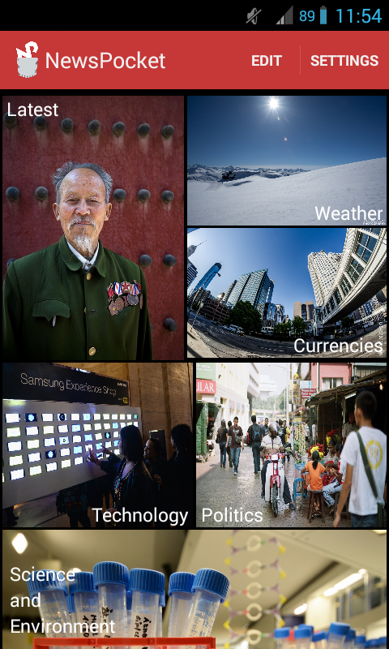

NewsPocket consists of 6 pre-determined news menu grids (Figure 1.0). All of the 6 grid news categories contain news relating to their category. All grids have icon and, additionally, its category name to allow convenience in distinction. The EDIT button directs the user to a series of news categories that the user wants to be displayed on the home page for easier access and importance. The SETTINGS button directs the user to the Settings page wherein he can change his settings for the application.

**Figure 1.0 News Grid Categories**

1. Latest News Page

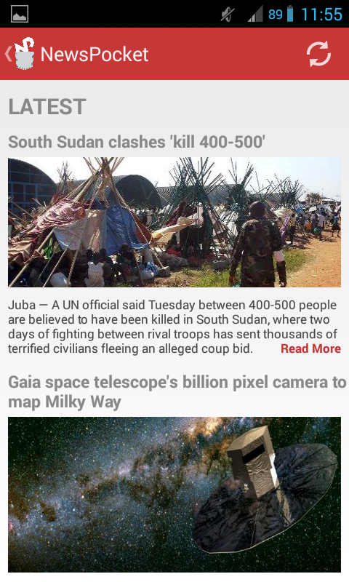

The Latest news page (Figure 2.0) can be accessed by tapping the Latest grid category. The page consists of the latest news that have been reported and gathered from around the globe from the time of the last application update. It contains a back (<) button that sends the user back to the news grid categories. A refresh button can be tapped at the upper right side of the header tab to update the current list of latest news. If the user desires to finish reading an article, he can tap on the ‘Read More’ button located at the lower right corner of each article.

**Figure 2.0 Latest News Page**

* 1. Weather Report Page

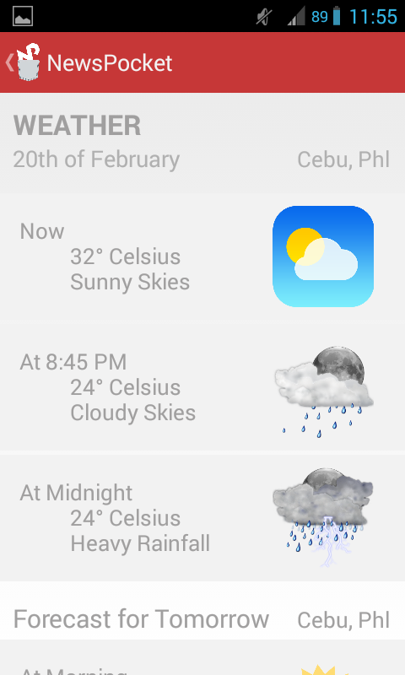

The Weather report page (Figure 3.0) can be accessed by tapping the Weather grid category. The page consists of the weather report for the current day and the day after that have been gathered from PAG-ASA from the time of the last application update. It contains a back (<) button that sends the user back to the news grid categories. A refresh button is located at the upper right side of the header tab to update the current list of latest news. Additionally, a Share button (three dots connected to one another) can be tapped to disseminate the information to the user’s family and friends.

**Figure 3.0 Weather Report Page**

* + 1. Currencies News Page

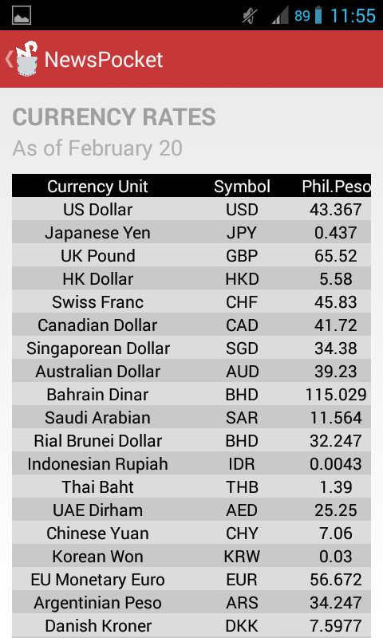

The Currencies news page can be accessed by tapping the Currencies grid category. The page consists of the latest economic and market status news that have been reported and gathered from around the globe from the time of the last application update. It has a back (<) button that sends the user back to the news grid categories. A refresh button is located at the upper right side of the header tab to update the current list of latest news.

Shown in Figure 4.0 are the currency rates which are in a separate category but also has to do with business and economy.

**Figure 4.0 Currencies News Page**

* + - 1. Science and Environment News Page

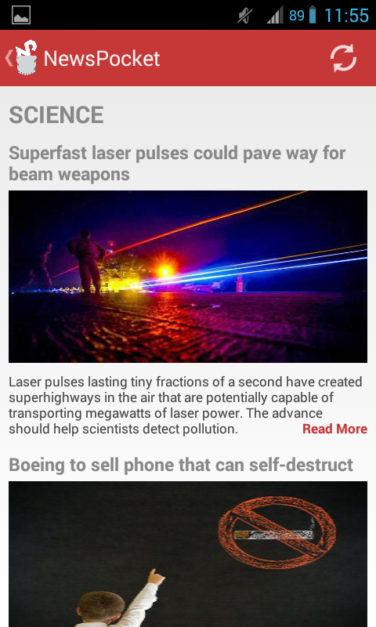

The Science and Environment news page can be accessed by tapping the Science and Environment grid category. The page consists of the latest discoveries, new scientific inventions and nature’s condition that is gathered from around the globe from the time of the last update. It has a back (<) button that sends the user back to the news grid categories. A refresh button is located at the upper right side of the header tab to update the current list of latest news.

**Figure 5.0 Science and Environment Page**

* + - * 1. Technology News Page

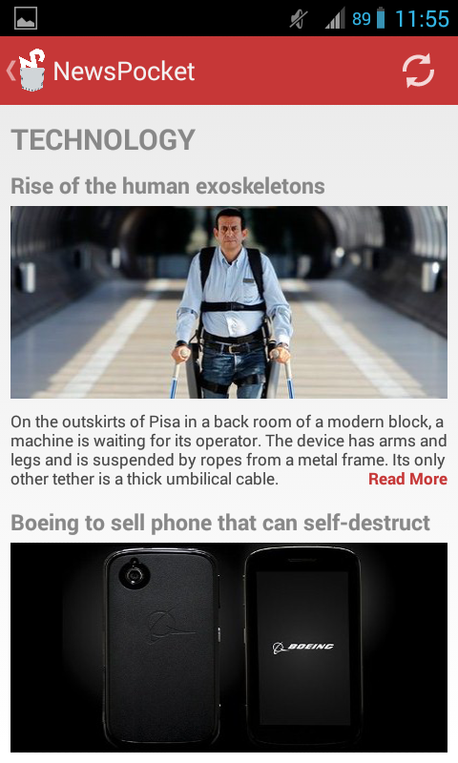

The Technology news page can be accessed by tapping the Technology grid category. The page consists of the newly released gadgets, trending games, videos, and sites that are gathered from around the globe from the time of the last update. It has a back (<) button that sends the user back to the news grid categories. A refresh button is located at the upper right side of the header tab to update the current list of latest news.

**Figure 6.0 Technology Page**

Politics News Page

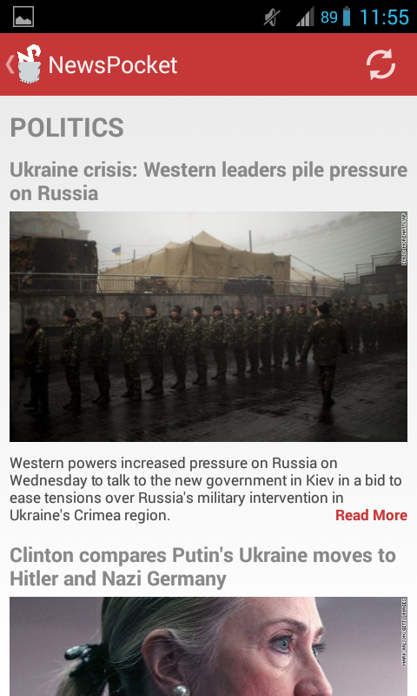

The Politics news page can be accessed by tapping the Politics grid category. The page consists of the current activities of the government and its officials that are gathered from around the globe from the time of the last update. It has a back (<) button that sends the user back to the news grid categories. A refresh button is located at the upper right side of the header tab to update the current list of latest news.

**Figure 7.0 Politics Page**

Chapter 5

Using the Application

This section provides a detailed description of system functions.

1. Screen Layouts

The screen layout can be modified by going to the Settings menu as seen in Figure 8.0. The Settings Menu can be accessed by tapping the SETTINGS button located in the news grid categories. The user can modify the orientation of the screen to either: Automatic, Portrait, or Landscape by tapping the Screen Orientation row under the General settings (see Figure 8.1). Also, the user can modify how often he would like his news to automatically update by tapping on Update Frequency under update Preferences settings (see Figure 8.2).

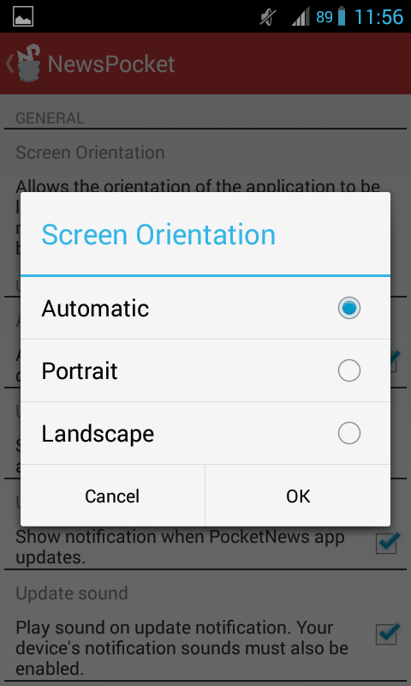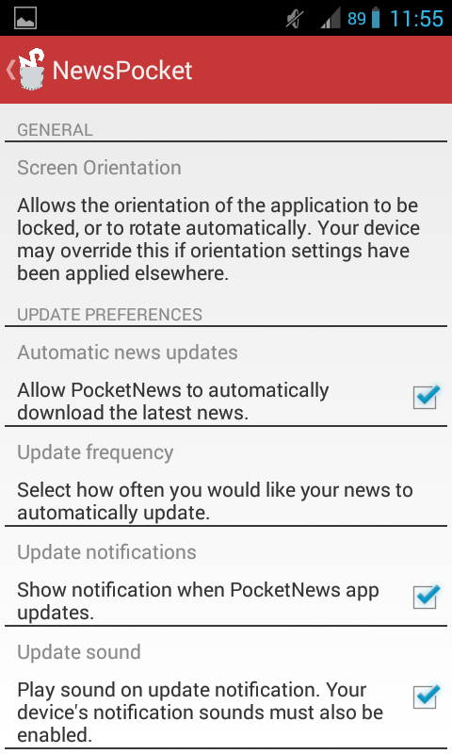

**Figure 8.1 Screen Orientation**

**Figure 8.0 Settings Screen**

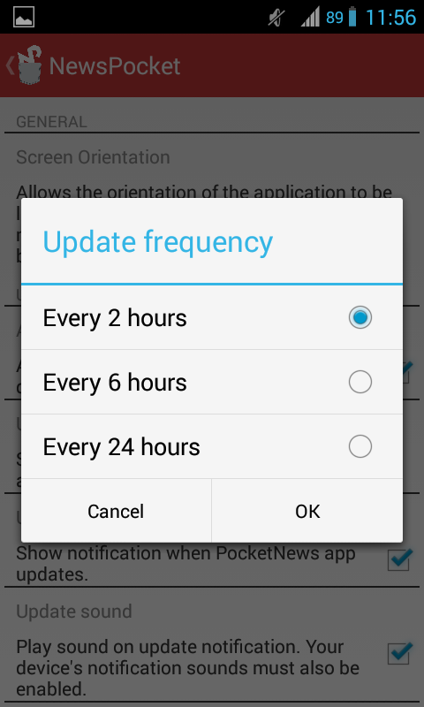

**Figure 8.2 Update Frequency**

* 1. Personalizing the News Grids

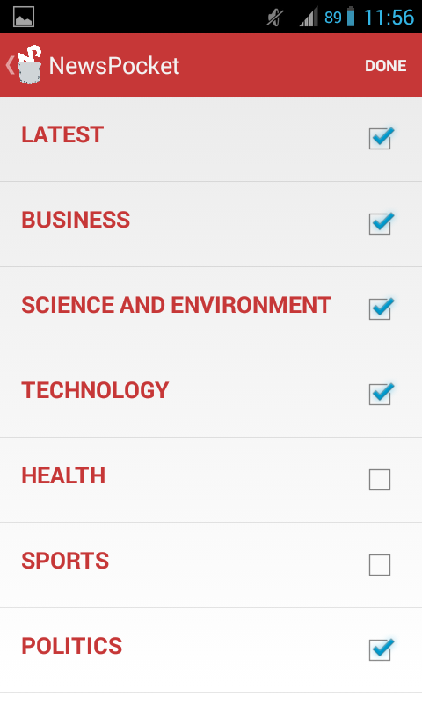

To personalize the news grids that will be displayed on the home page of the application, tap on the EDIT button located at the upper right corner in the news grid categories.

The list of different news categories is composed of check boxes which makes the selection for the user easier.

Figure 9.0 shows you the different news categories.

**Figure 9.0 News Category**

* + 1. Sharing a News

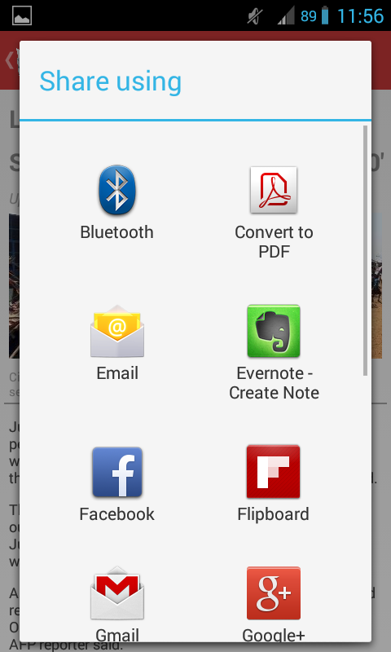

**Figure 10.0 Share**

The share button activates a pop-up window (see Figure 9.0) if the user wants to tell his friends or family about the news he has read, or simply archive it for themselves through online media. Most of the media listed need internet connection to complete the action of sharing the news.

For the user to choose the media they want to share it from, simply tap the media desired.